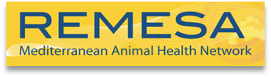
 | 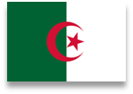 | 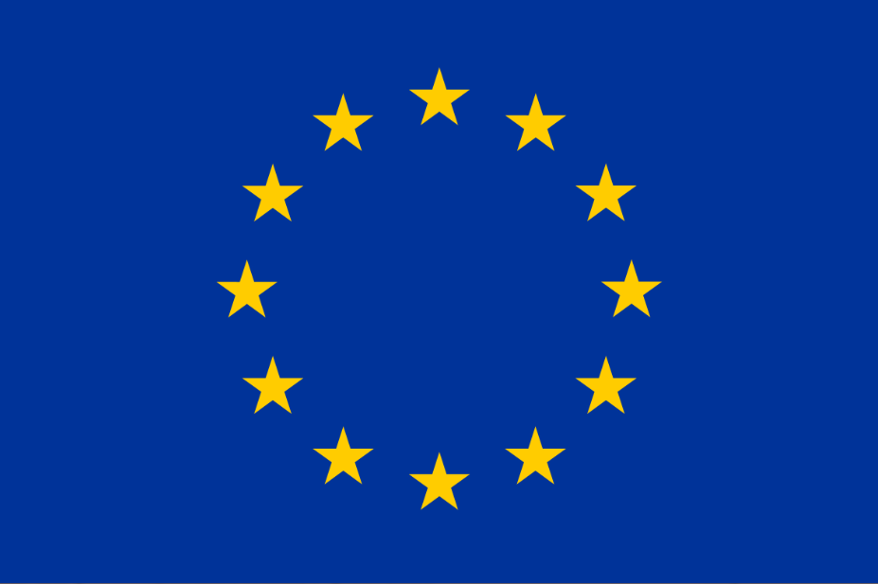 | 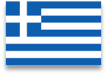 | 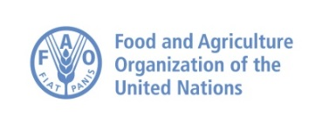

Provisional Agenda of the 21th JPC/REMESA 2020- co-chair : Algeria – Greece
Video-conference
16 December 2020 (10:00 – 13:00 CET)

 | 16 December 2020
 | Time | Theme / Speaker
 | Opening Session: Presidency Greece
 | 10:00-10:15 | SESSION – WELCOMING  - Co-presidents: Chrysoula Dile (CVO Greece) and Dr Ahmed Chawki El Karim Boughalem (CVO Algeria)  - Director General of OIE  - CVO of FAO
 | Presidency Greece
 | 10:15-10:20 | Approval of the agenda
 | 10:20-12:00 | SESSION - UPDATES OF EVENTS:  - Updates on major events occurred in the Mediterranean Region (sanitary, OIE initiatives) – (OIE Tunis)– Dr Rachid Bouguedour (OIE Sub regional Representation for North Africa)  - Mission RVF in Mauritania (FAO)  - Countries updates (each country has the possibility to share any relevant major updates about sanitary events):  - EuFMD support to REMESA: activities carried out and priorities for the region– EuFMD – 10 minutes  CNVZ OIE Collaborating Center for training and reinforcement of capacities in the veterinary domain: state of play and perspectives (Dr Mohammed Nacer Baccar, CNVZ, Tunisia)  Discussion
  Algeria | Cyprus | Egypt | France | Greece
  Italy | Jordan | Lebanon | Libya | Malta
  Mauritania | Morocco | Portugal | Spain | Tunisia
 | 12:00-12:10 | Coffee break
 | Presidency Algeria
 | 12:10-12:40 | SESSION ON “REMESA GOVERNANCE”:  - Governance:  - Strategic Note – Introduction by the Secretariat OIE/FAO  Discussion
 | Presidency Algeria
 | 12:40-12:50 | REMESA Unit Palermo – state of play, ongoing activities and next steps (Italy)
 | 12:50-13.00 | Next Co-presidency  Next JPC meeting
 | 13.00 | Wrap up and closing remarks

